

✓

✓

✓

|  |  |  |
| --- | --- | --- |
|  |  |  |

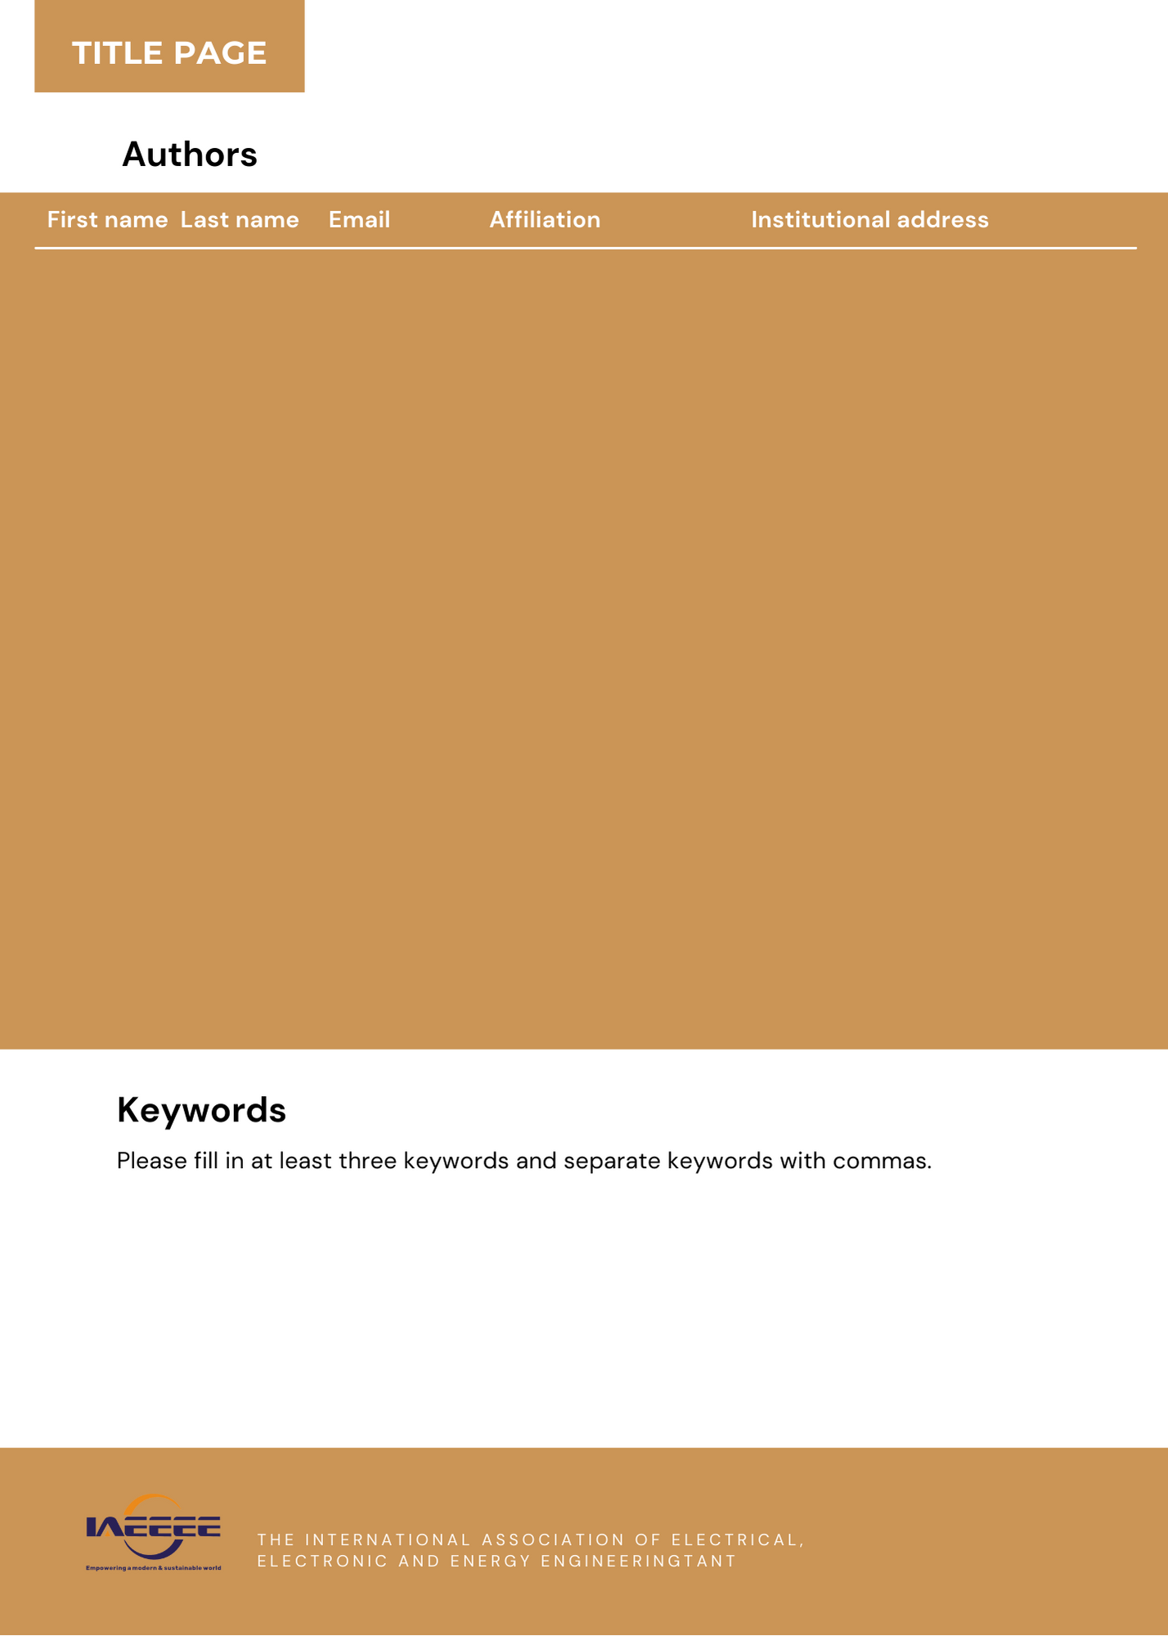

|  |  |  |  |  |
| --- | --- | --- | --- | --- |
|  |  |  |  |  |
|  |  |  |  |  |
|  |  |  |  |  |
|  |  |  |  |  |
|  |  |  |  |  |

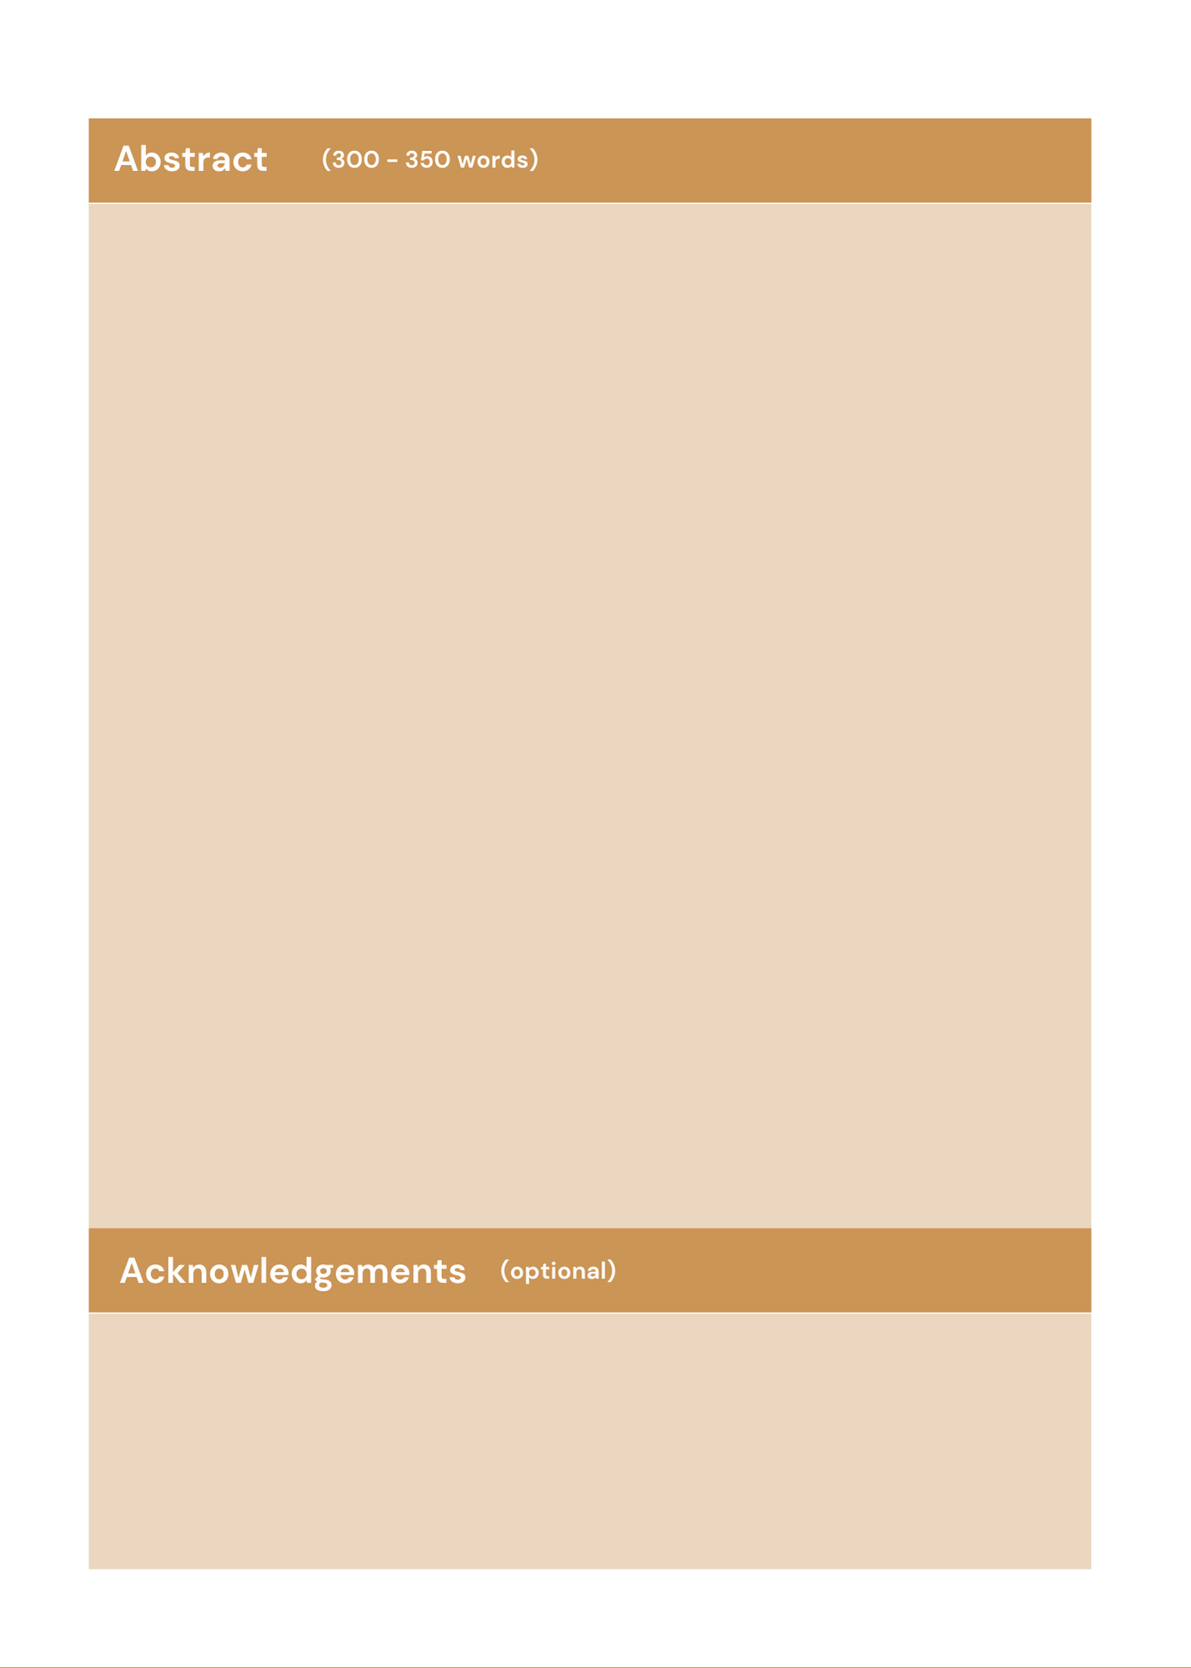

(Your abstract should briefly explain the salient aspects of your paper content, it needs to be accurate, succinct, self-contained, and readable. Please limit your abstract within 300 - 350 words and do not include any references in your Abstract.)

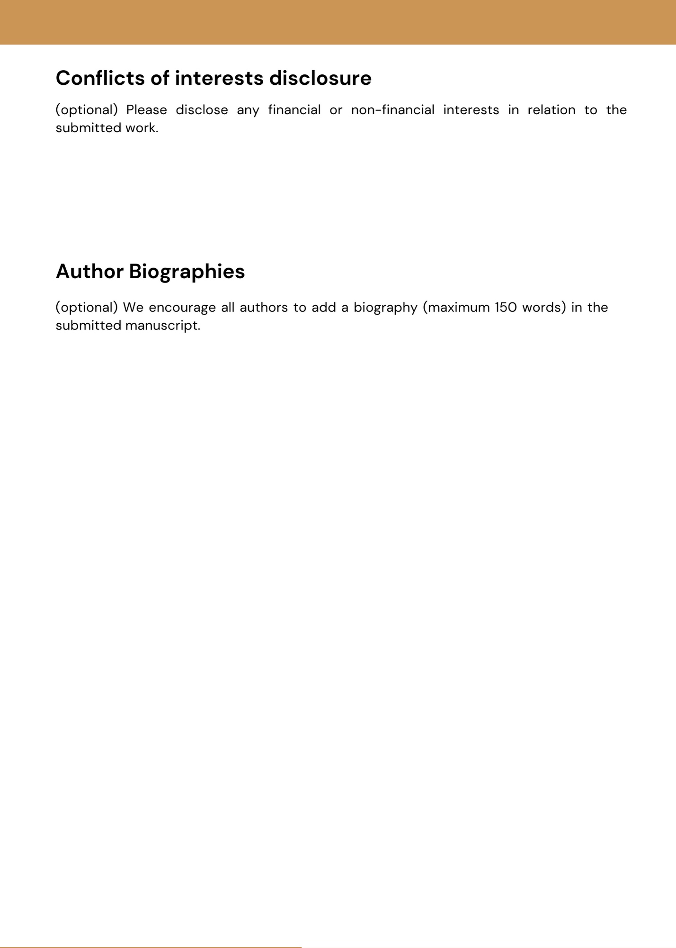

|  |  |
| --- | --- |
| **Full Name** | **Brief Bio** |
|  |  |
|  |  |
|  |  |
|  |  |
|  |  |



[email@cybersecurityworkshop.org](mailto:email@cybersecurityworkshop.org)